과제 - 06

문제가 이해가 안되면 영어 원서를 참고하시오.

1. 교재 279페이지의 10번을 프로그램하여 아래에 붙이시오.

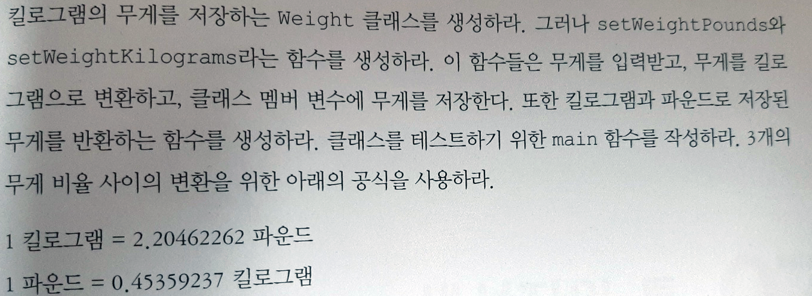

|  |
| --- |
| #include<iostream>  using namespace std;  class Weight {  private:  double pounds;  double kilograms;  public:  void setWeightPounds();  void setWeightKilograms();  double output_pounds();  double output_kilograms();  };  int main()  {  Weight in_pounds;  //입력  in_pounds.setWeightPounds();  in_pounds.setWeightKilograms();  //출력  cout << in_pounds.output_pounds() << " pounds" << endl;  cout << in_pounds.output_kilograms() << " kilograms" << endl;  return 0;  }  void Weight::setWeightPounds()  {  cin >> pounds;  }  void Weight::setWeightKilograms()  {  kilograms = pounds * 0.15359237;  }  double Weight::output_pounds()  {  return pounds;  }  double Weight::output_kilograms()  {  return kilograms;  } |

[출력 결과] (화면 캡쳐하여 복사)

